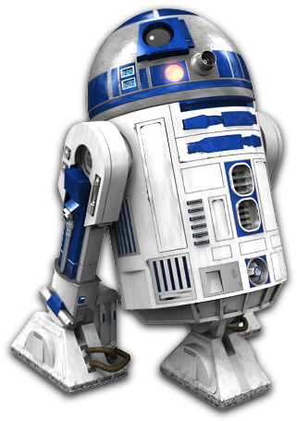**Table of Contents**

USAFA DFEC 2017-2018 Capstone Project

Mentor – Maj Walchko

Members – C1C Anthony Talosaga, C1C Hwi Tae Kim, C1C Brayden Thomas, and C1C Mario Bracamonte

**R2-D2**

Operation Manual

Safety Measures………………………………………………………………………..Page 3

R2-D2 Terminologies…………………………………………………………………Page 4-6

Operation Procedures……………………………………………………………….Page 7-8

Keypad Controls…………………………………………………………………………Page 9

PS4 Controls………………………………………………………………………………Page 10

Battery and External Power……………………………………………………..Page 11-12

Troubleshooting…………………………………………………………………………Page 13-15

**Safety Measures**

* Press EMS switch to shut down all motors during an emergency situation
* Have a fire extinguisher in close proximity for fire hazards
* Do NOT connect the charging plug and external plug at the same time!
* Ensure battery is at a minimum of 20% to prevent discharge malfunctions
* Make sure to unscrew one of the battery terminal if battery is not used
* Dispose old batteries properly
* Current R2-D2 wheels (as of May 2018) are only compatible to drive inside Fairchild hallways
* Avoid nearby stairways at all times
* Avoid driving R2-D2 at full speed to prevent collision with nearby people
* Seek professional assistance if the troubleshooting methods in this manual does not fix any software, electrical, or mechanical problems

**R2-D2 Terminologies**

(Front View)

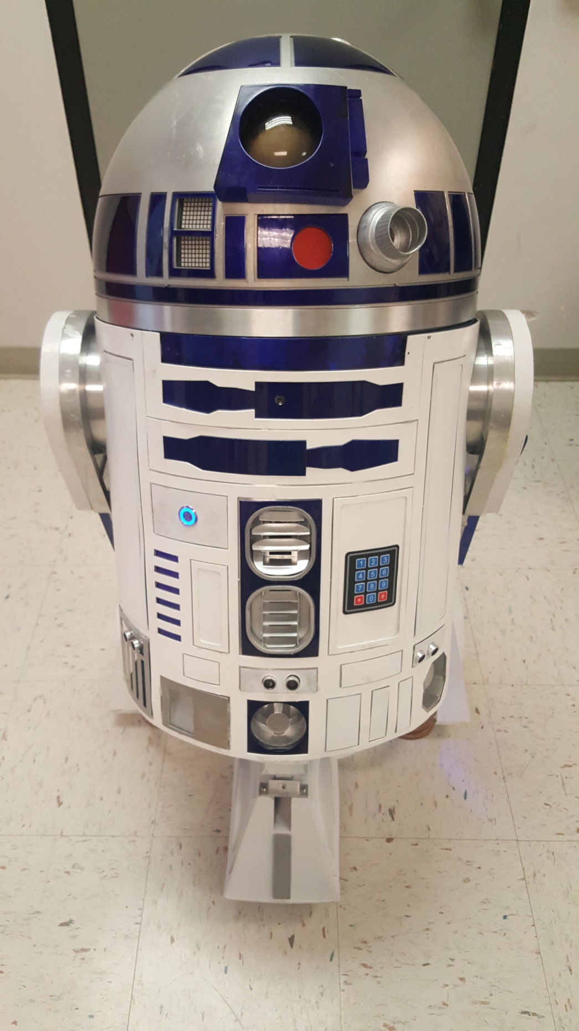

Front Sensor

Flashlight

Camera

Keypad

Left Sensor

Right Sensor

Power Button

LED Arrays

(Back View)

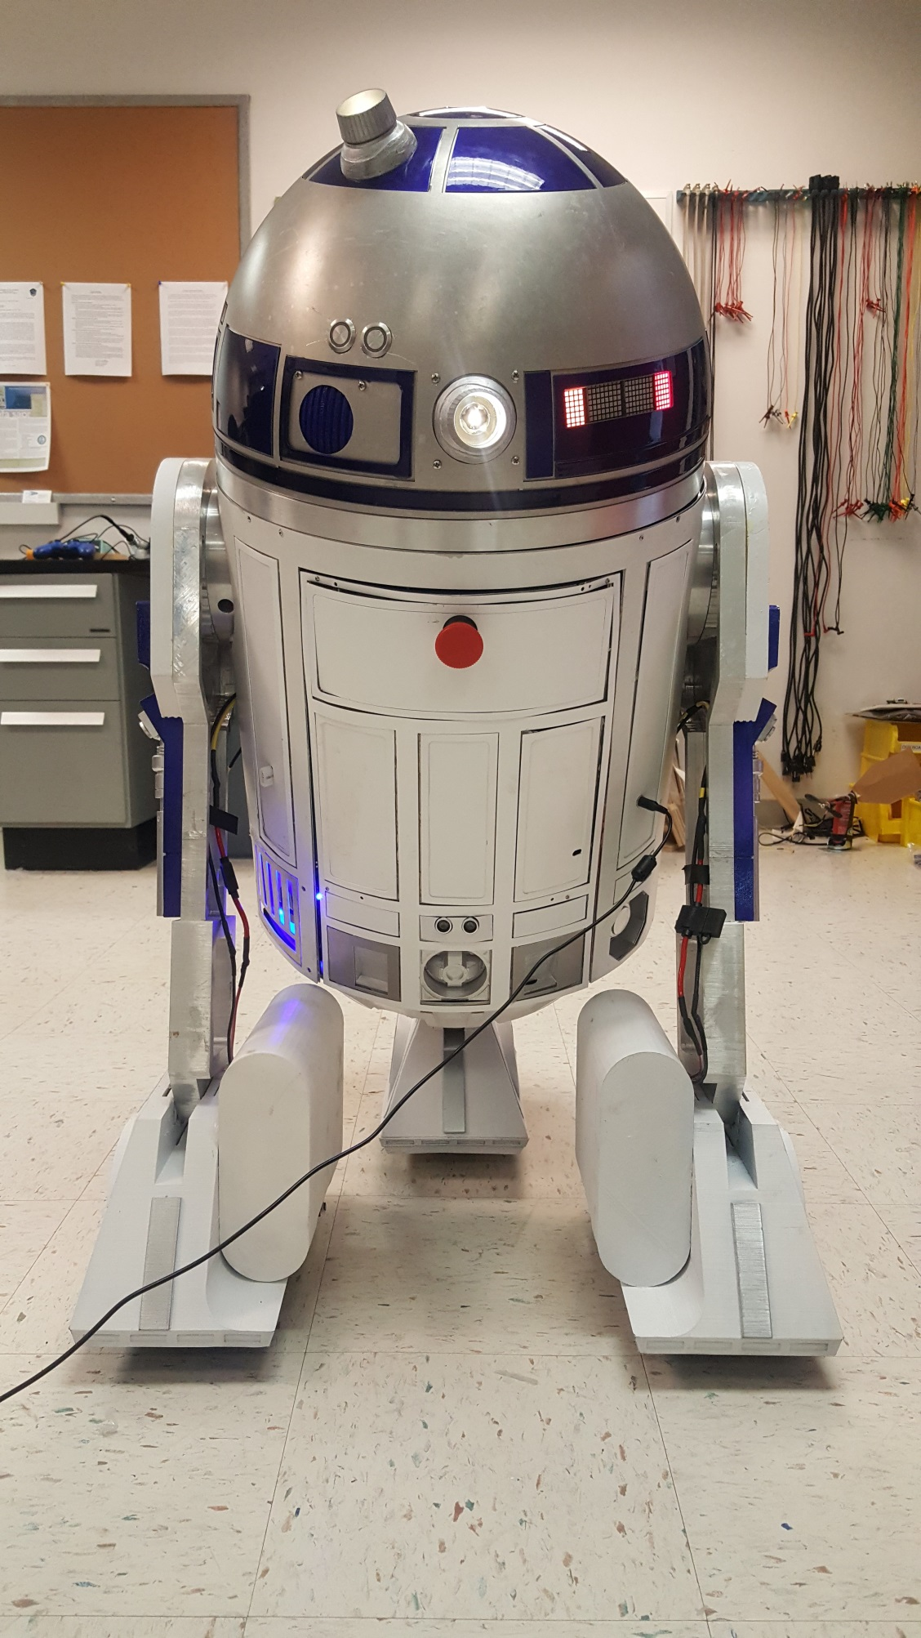

External Power Plug

Flashlight

Mode Indicator

Charging Plug

EMS Switch

Speaker

Flashlight

Right Motor Fuse

Battery Meter

Fan

Left Motor Fuse

Back Sensor

(Left View)

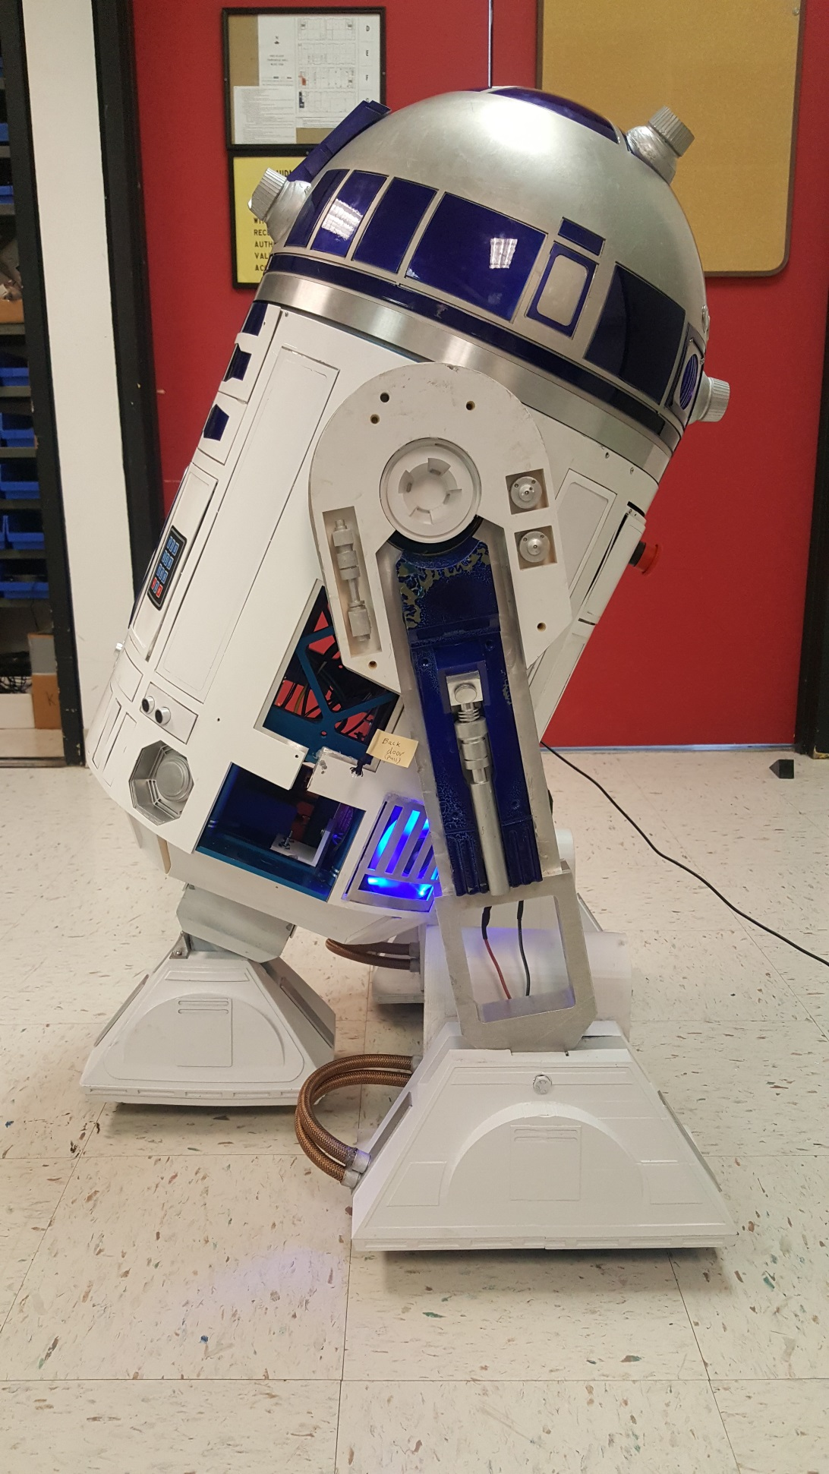

Flashlight

Flashlight

Flashlight

Fan

Back Door Opener

Left Sensor

**Operation Procedures**

1. - Press the power button to turn ON power (if using battery)

- Plug in external power plug (if using external power)

1. - Wait for “Window XP” startup sound to play (signals startup success)

- If power fails, turn power button OFF/ON or unplug/plug external power

1. - Afterwards, connect PS4 controller by pressing and holding the “share” and “PlayStation” button together until the blue light starts blinking.

- Connection is successful when the blue light stops blinking and turns dark blue.

- Connection is unsuccessful when the blue light stops blinking and/or turns light blue.

- If connection is unsuccessful, try re-connecting the PS4 controller or restart the entire system by pressing the “Reboot” button on the keypad.

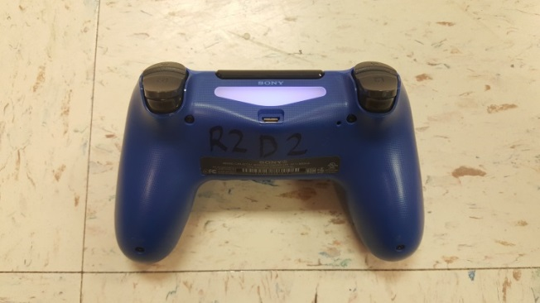 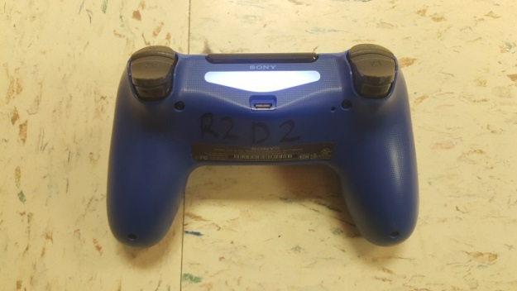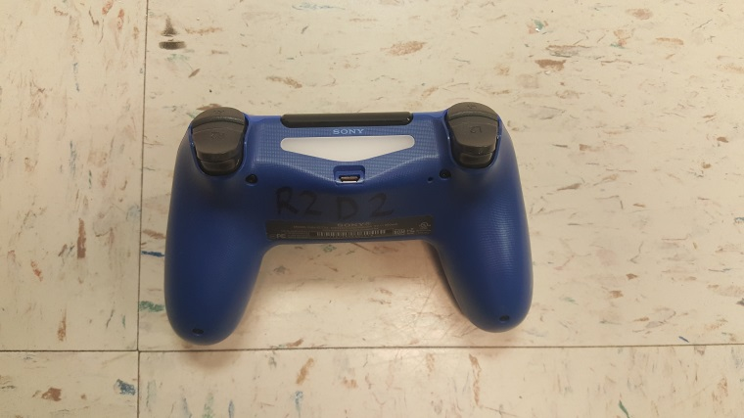

**NOT Connected!**

**NOT Connected!**

**Connected**

1. - Press number 1 on keypad to activate “Standby” mode or safe mode

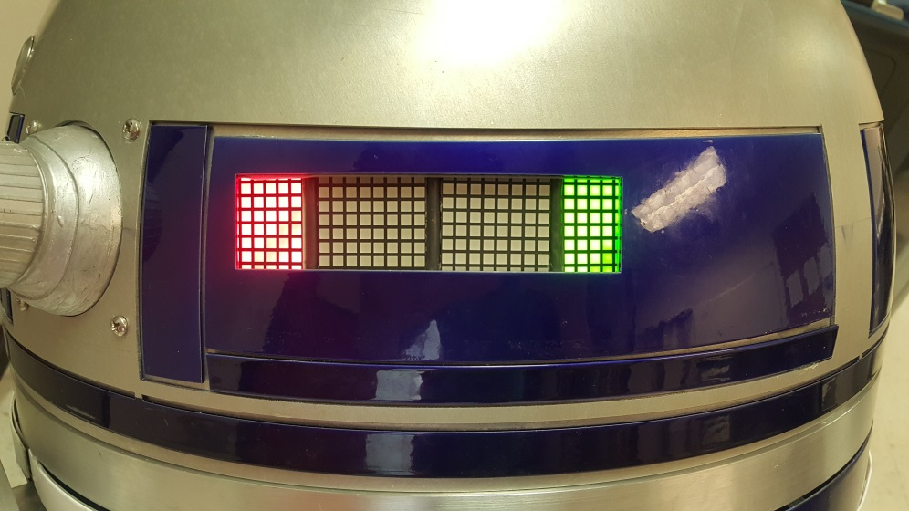

“Red” Color Indicator

1. - Press number 2 on keypad to activate “Static display” mode

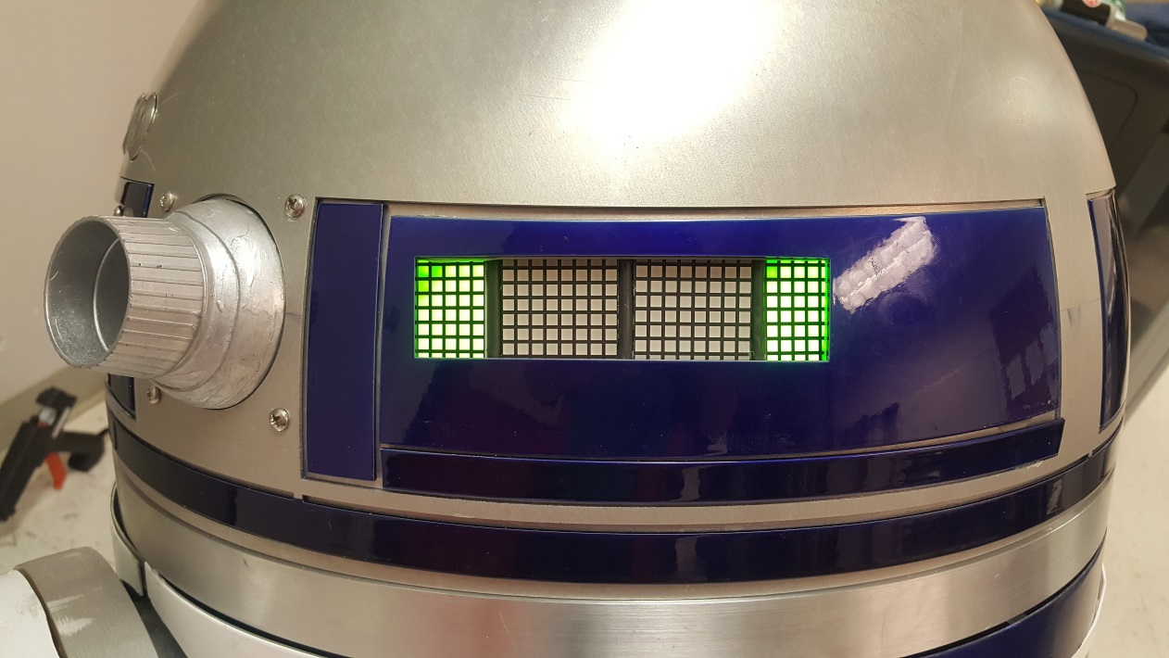

“Green” Color Indicator

1. - Press number 3 on keypad to activate “Remote” mode

- You can only use PS4 controller during “Remote” mode

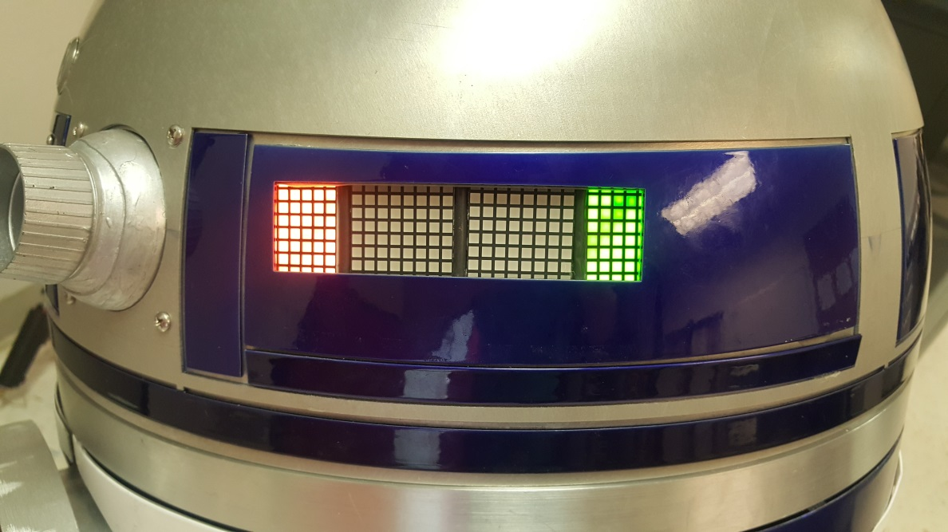

“Orange” Color Indicator

1. - Press number 4, 5, or 6 on keypad to activate “Happy”, “Chill”, or “Angry” emotions

1. - Press the star key (*) to reboot/restart the system
2. - Press the pound key (#) to shut down the system

- The “Window XP” shutdown sound will play immediately

- After 15 seconds, press the power button to turn OFF the power

**IMPORTANT** 🡪 Press EMS to shut down all motors during an emergency situation

Go to this link for a quick Demo 🡪 <https://youtu.be/QTvInzK1VoA>

**Keypad Controls**

1. Mode selection buttons:

- Press number 1 for “standby” or safe mode

- Press number 2 for “static display” mode

- Press number 3 for “remote” mode

1. Emotion selection buttons:

- Press number 4 for “Happy”

- Press number 5 for “Chill”

- Press number 6 for “Angry”

1. Software power buttons:

- Press (*) for “restart/reboot”

- Press (#) for “shutdown

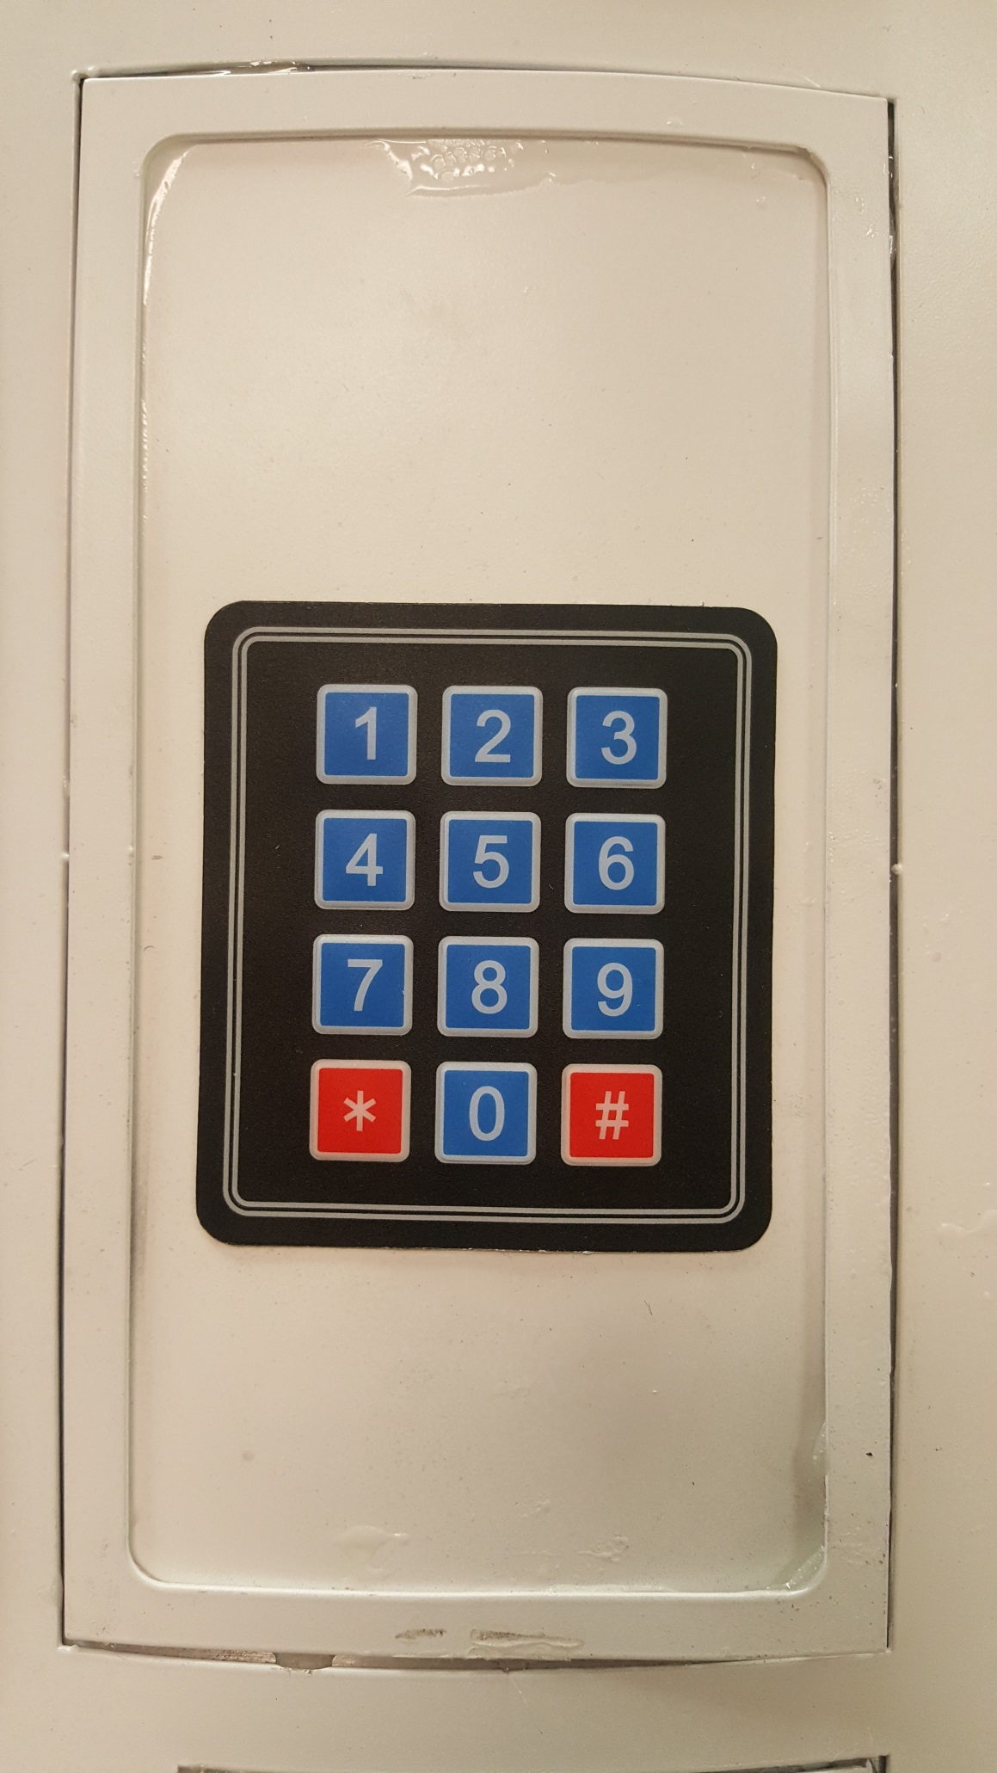

Mode Buttons

Emotion Buttons

Reboot/Restart

Shutdown

**PS4 Controls**

Share button

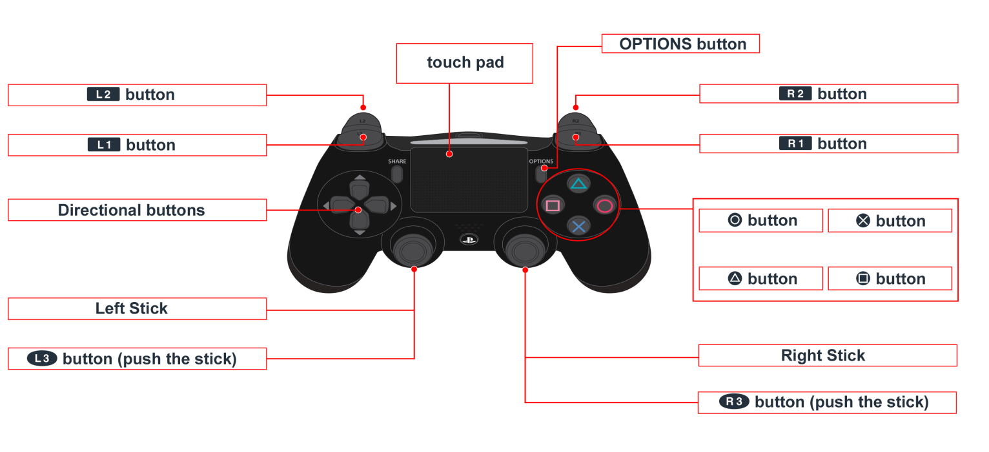

PlayStation button

Triangle – Turn ON flashlights

Circle – Turn OFF flashlights

Square – R2-D2 talking

X – Random LED array patterns

Up button – “Happy” emotion

Left button – “Chill” emotion

Right button – “Angry” emotion

Left joystick (push left) – Turn left

Left joystick (push right) – Turn right

Right joystick (push up) – Move backward

Right joystick (push down) – Move forward

R1 button – Turn dome clockwise

L1 button – Turn dome counter clockwise

R2 button – Close dome panels

L2 button – Open dome panels

Share + PlayStation buttons – Connect PS4 controller to R2-D2

**Battery and External Power**

**Battery Replacement:**

1. Ensure power button is OFF
2. Open and close back door using back door opener (strap) on the left side
3. Unscrew battery terminals and disconnect battery strap
4. Remove old battery and insert new battery
   1. Recommend Lithium Iron Phosphate 12V 35Ah (or higher) battery
5. Connect strap and screw in battery terminals
   1. Unscrew one terminal if battery is not currently in used

**External Power Plug:**

* Do NOT connect the charging plug and external plug at the same time!
* Ensure one of the battery terminals is disconnected when using external power

**Charging Plug:**

* Do NOT connect the charging plug and external plug at the same time!
* Utilize “Battery Meter” to keep track of battery power percentage
* Ensure battery is at 20% or higher to prevent discharge malfunctions

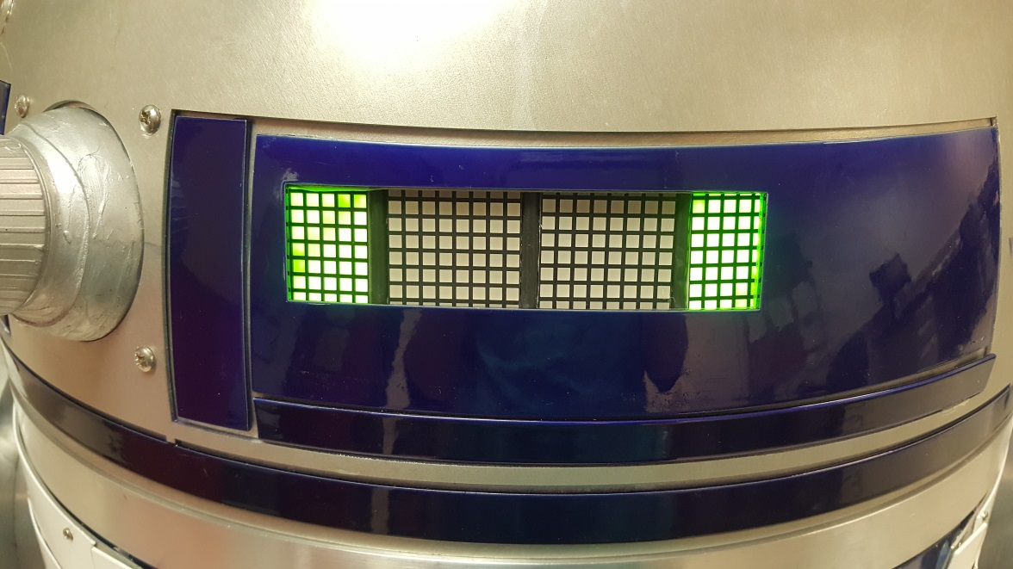 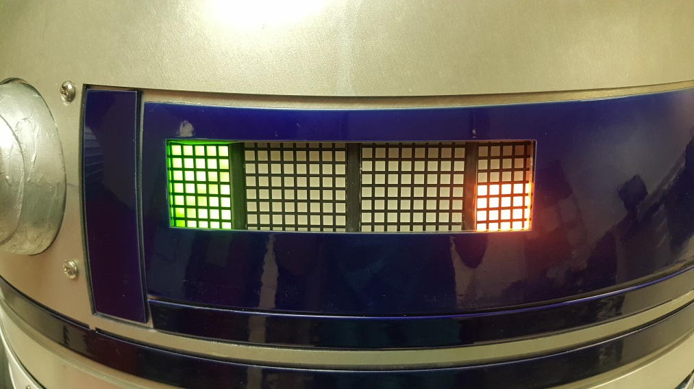

**50% Battery**

**100% Battery**

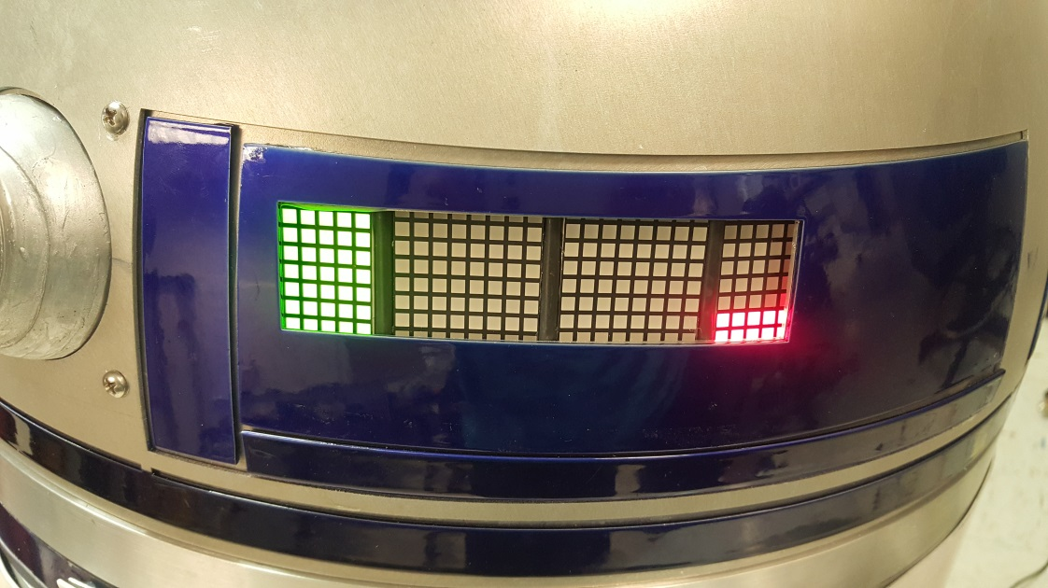 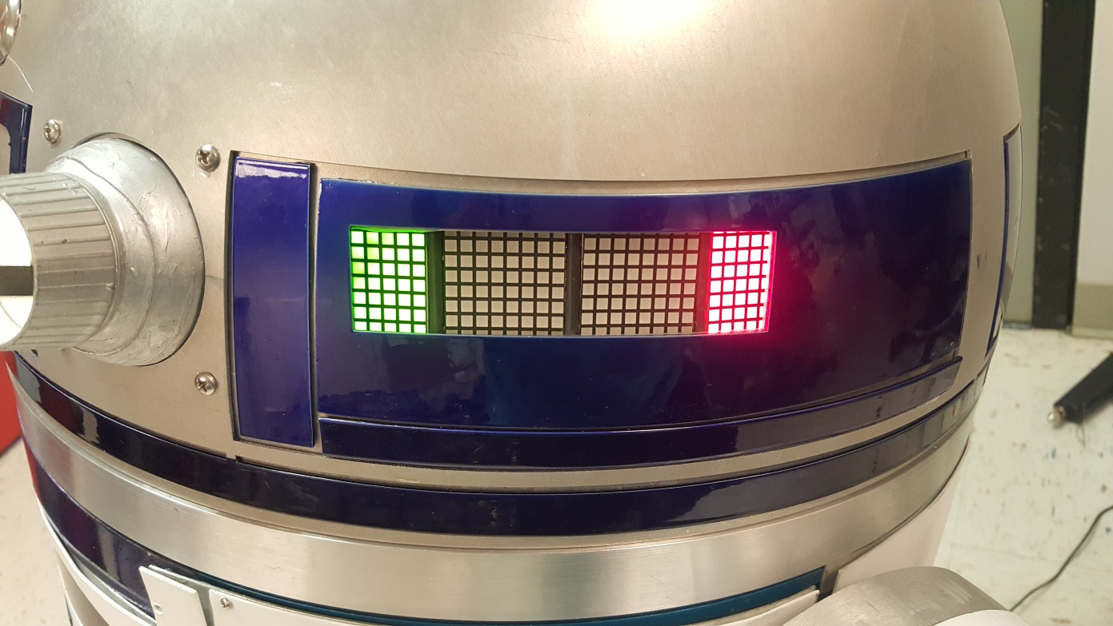

**0% Battery**

**25% Battery**

* Battery can be charged inside of R2-D2 by connecting the charge plug
* Battery can also be taken out and charged using the external charge plug
* A fully charged battery (10% to 100%) takes at least 3 hours

**Troubleshooting**

**Software:**

* If “Window XP” startup sound does not play 30 secs after startup, turn power button OFF/ON or unplug/plug external power plug
* If keypad does not work after a successful startup, turn power button OFF/ON or unplug/plug external power plug
* If all other electronics, except the keypad, does not work after a successful startup, press the star key (*) to reboot – Do NOT turn OFF power button
* If PS4 controller does not connect after 3 disconnecting/reconnecting tries, press the star key (*) to reboot – Do NOT turn OFF power button
* If any electronic glitches (especially the sensors, speaker, and keypad)…

1. Press number 1 on keypad twice for “Standby” mode
2. Press the star key (*) to reboot
3. Otherwise, turn power button OFF/ON for hard reset

* If a motor glitch occurs, press EMS switch for emergency situation before turning power OFF/ON or unplug/plug external power plug
* Seek professional assistance regarding code modification on Raspberry Pi and Arduino (user can connect HDMI and USB cables by accessing the control panel through the back door) – Warning: code modification can break the original R2-D2 program code

**Electrical:**

* Consider troubleshooting “software” first before troubleshooting any electrical issues
* Ensure power button is turned OFF, battery terminals disconnected, external power plug disconnected, and charging plug disconnected before troubleshooting
* Consider wearing safety glasses to prevent any eye injury
* If any electrical components does not work after a successful startup, open the back door to check any wire disconnection on the control panel and dome area
* If the dome motor does not work…

1. Check that EMS switch is OFF
2. Otherwise, check for mechanical problems

* If one of the leg motors does not work…

1. Check to make sure EMS switch is OFF
2. Check if the fuse is burnt or not – If so, change fuse (20 A min)
3. Otherwise, check for mechanical problems

* Seek professional assistance for more serious electrical issues

**Mechanical:**

* Ensure power button is turned OFF, battery terminals disconnected, external power plug disconnected, and charging plug disconnected before troubleshooting
* Consider troubleshooting “electrical” issues first before troubleshooting for mechanical problems
* If dome head does not spin, check to make sure that dome motor axel is not loose – if so, consider 3D printing another axel or getting another metal axel
* If a leg wheel does not spin, check to make sure the motor axel is not loose – if so, tighten the axel or consider getting a new axel gear if broken
* If squeaky sounds becomes noticeable, put some oil or WD-40 on the wheel chain
* If any skin panel falls off, recommend reattaching skin with epoxy
* Seek professional assistance for any other mechanical problems



**Thank You!**

**Enjoy R2-D2**